Military Survey (Geographic) Association
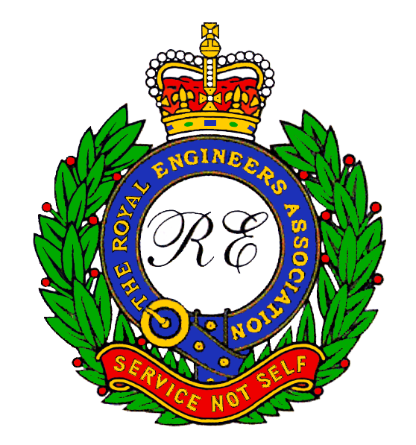
A member of the Royal Engineers Association
13th ANNUAL GENERAL MEETING
At the
WOs & Sgts Mess
Friday 07 September 2012

ATTENDEES

Members Name Guest

Avenell RJ Bob
Beale BF Brian
Beeston A Alan w/Susan
Brown K Keith (Joe)
Candy Clive
Codd Bill Joanna Burrows
Cross AP Gus
Eady J John
Field A Albie
Gordon AA Alan
Gowlett MJ Mike
Hall K Ken
Hughes BJ John
Hughman Tom w/Jean
Hyde J Jim
Isherwood AD Alf
Jefferies AC Tony w/Sara
Johnson D Dave
Lovell A Adrian
Mason JRV John
Nash CGA Chris
Nolan M Mike
Notage ML Mick
Perry M Mick
Price CR Collin
Siggs RB Rod
Vickers MH Mike (Vick)

